When teachers login to EasyBridge for the first time, they need to perform the step of adding products to their classes of rostered students. Click on the **Add Products** button:

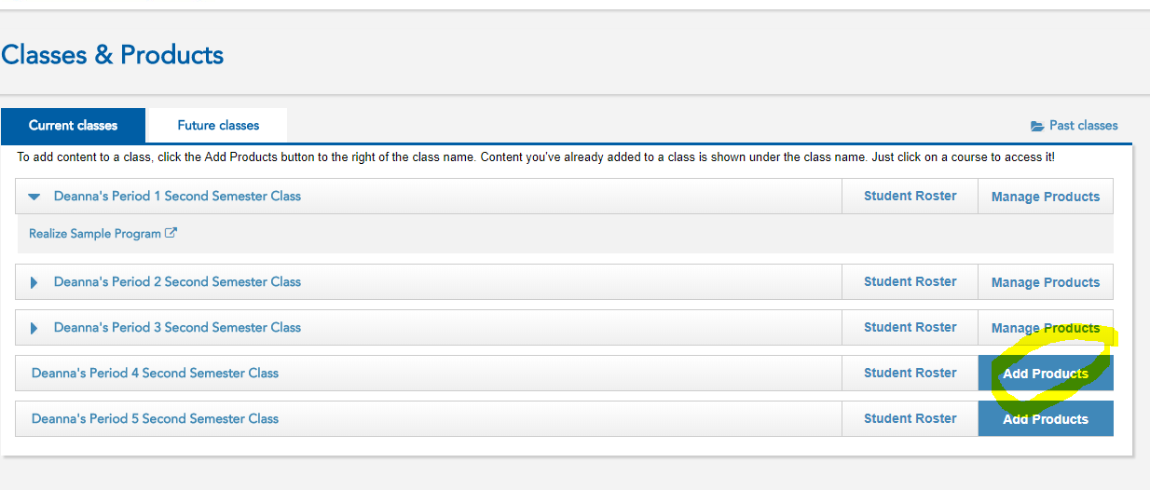

Select the product for that class and click **Save:**

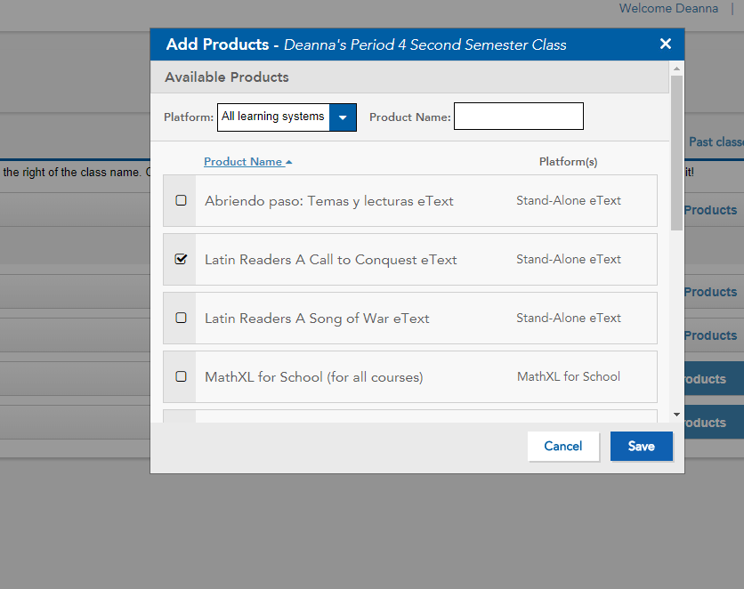

Following performing this step, the **Add Products** button will change to **Manage Products**. Click on the product listed below the class to launch directly into the platform.

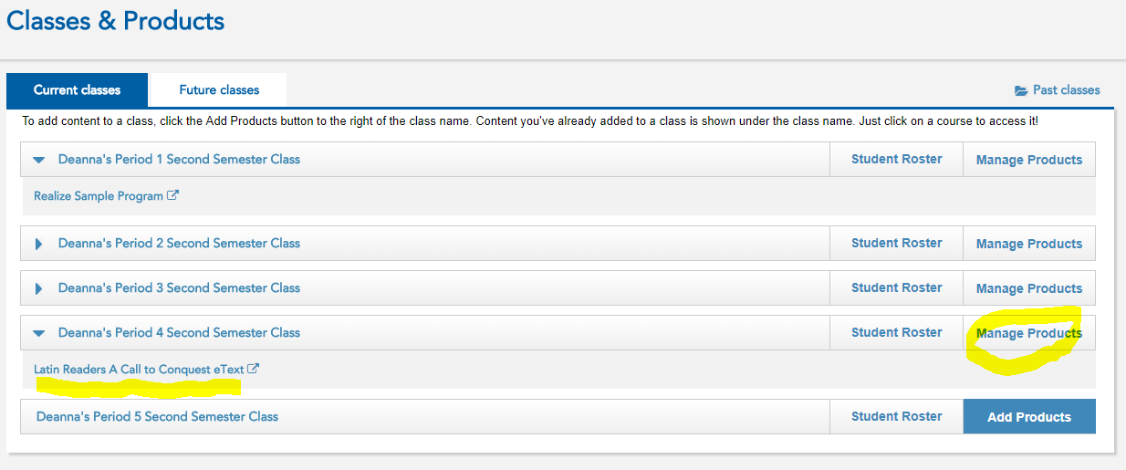

Students will receive this message if the Add Products step has not been performed:

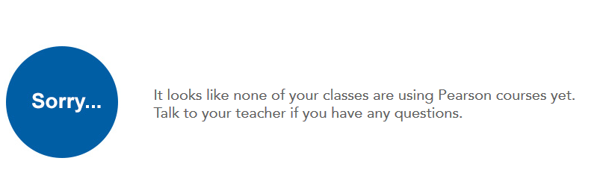

Please remember, the first time Teachers or Students access Realize products in EasyBridge, they will need to consent to the license agreement. If they don’t, they will not be able to move beyond the license agreement page.